Responding to a Critical Incident
Tír Eoghain GAA

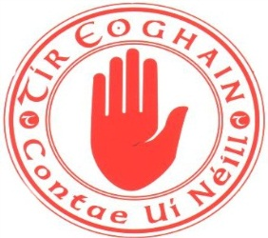

Critical Incident Response Plan
Tír Eoghain
Lead Liaison Person: Health &Wellbeing Alternate Liaison Person: Cathaiorleach Cathaiorleach Coiste Contae Roisin Jordan
Fiona Teague

Contact Number: 07813935996 Contact Number: 07712873386
Alternate No: 02885567723 Alternate No: 02885567723
Email: chair.hwc.tyrone@gaa.ie Email: chairperson.tyrone@gaa.ie

Support Team:
Name: Dominic McCaughey (County Secretary) 02885567723
Name: Ciaran McLaughlin (County HWC member) 07894642984

Media Liaison Person:
Name: Eunan Lindsay (County PRO) 07714254903

Key Role: Consult with the club officials from the club concerned to establish if any support is required from the county officials.

Key Duties: Ensure club has information on any local appropriate support services available.

The GAA, its clubs and counties provide great support during and after all manner of incidents that may have traumatic or tragic consequences for members and their communities. This natural response by clubs usually requires no external expertise or input. Nonetheless, it has been identified as an invaluable support to those involved. However some situations can overwhelm even the most experienced and well prepared GAA officers and units. This critical incident plan is designed to offer some assurance about what steps to take in such situations, while also highlighting that other support services – both within the GAA and external to it – are available should they be needed. All it takes is a phone call. That reassurance can be invaluable in times of stress.
Key point – it is normal to experience all kinds of unpleasant feelings, emotions and body sensations following abnormal events
A critical incident is any event that is outside the range of usual human experience. It is an event that causes an unusually intense stress reaction which has the emotional power to overwhelm an individual’s ability to cope. It may impede people’s coping mechanisms immediately or in the future following the event.
(GPA/GAA guidelines 2014)

Examples of Critical incidents may include:
- Death or serious injury on or off the playing field
- Exposure to the aftermath of a road traffic collision eg; the accident scene, the victim(s)
- Personal loss or injury, real or threatened to a child or adult
- Being violently threatened
- Close encounter with death
- Suicide of a club member (This tragic situation can cause extreme distress and confusion for everyone involved. Guidelines developed by professional services highlighting the most appropriate responses are available see appendix
- A situation with excessive media interest
- A natural disaster or act of God
- Other incidents not covered above but which are associated with unusually strong emotional reactions.

Introduction

A critical incident is any event that is outside the range of usual human experience. It is an event that causes an unusually intense stress reaction which has the emotional power to overwhelm an individual’s usual ability to cope. It may impede people’s coping mechanisms immediately or in the future following the event. (GPA/GAA guidelines, 2014)

Sometimes a critical incident – one that overwhelms ones natural capacity to respond – will
arise leaving individuals or communities struggling to cope. GAA clubs and counties have proven themselves invaluable in supporting their members’ and communities in responding to an array of tragic and seemingly insurmountable situations.
However, sometimes our units need support in responding to critical situations too. This document has been developed by Tír Eoghain CLG for its clubs should they require it.
Tír Eoghain have implemented the recommended ‘five step plan’ and has developed key roles and duties for identified individuals. (named in page 1)

Clubs are encouraged to develop their own critical incident plans. Templates and further information on developing a critical incident plan are available from the community health and wellbeing website; http://gaaclub.ie/gaa-responding-to-a-critical-incident/

Examples of critical incidents may include:
• Death or serious injury on or off the playing field
• Exposure to the aftermath of a road traffic accident e.g. the accident scene, the victim(s)
• Personal loss or injury, real or threatened to a child or adult
• Being violently threatened, Close encounter with death.
• Suicide of a club member (this tragic situation can cause extreme distress and confusion
for everyone involved. Guidelines developed by professional services highlighting the most
appropriate responses following a death by suicide by sporting organisations are available.
Some of this information has been included in a special section on suicide in the Appendix
section of this resource.)
• A situation with excessive media interest, A natural disaster or act of God.
• Other incidents not covered above but which are associated with unusually strong emotional reactions.

What clubs can do

Figure 1: Recommended avenues for communicating a critical incident.

Incident reported to County Chairperson
County Chairperson informs Health & Wellbeing Chairperson
Health & Wellbeing Chair informs Ulster Council Health & wellbeing manager and Croke Park

Our role in responding to critical incidents
It’s important to remember that the GAA will usually be just one entity playing a part in any response to a critical incident. Figure 2 outlines some of the other entities that may be involved in a response. It also highlights the importance of having the affected family or families at the centre of any plan while being consulted on all actions. Other at risk persons will be to the forefront of considerations too.
It is important try to follow these 5 Key Principles during any crisis situation or critical incident.
Key point – Always consult with those affected to see what level of support they want/need.

1. Promote a sense of safety
2. Promote a sense of calm
3. Promote a sense of self-efficacy (i.e. the capacity to deal with the situation)
4. Promote connectedness
5. Promote hope

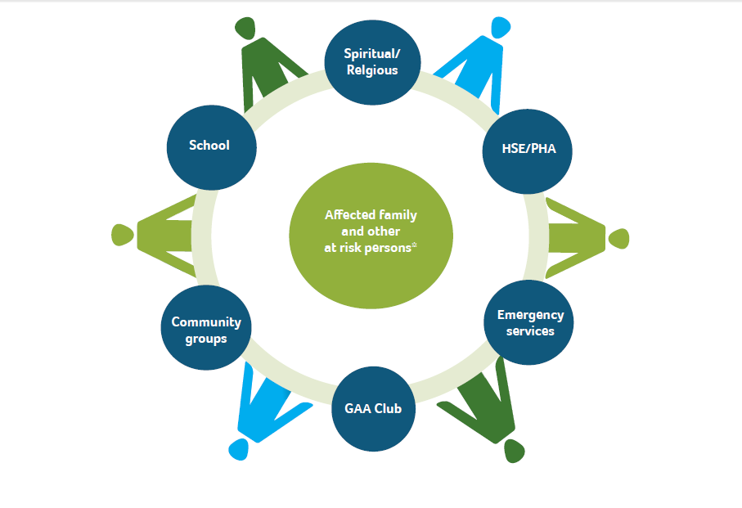
Figure 2: Some potential participants involved in a community based response to a critical incident.
Who requires support?
In addition to the individuals directly affected, other ‘at risk’ persons are amongst those most likely to suffer distress as a consequence of an incident. Evidence would suggest that these may include those who:
• directly witnessed death/injury/violence as part of the incident
• are uninjured, but were at greatest risk
• are siblings of those immediately affected
• may blame themselves and/or those who may be blamed by others
• are experiencing instability at home
• have learning difficulties
• have pre-existing emotional and behavioural/mental health difficulties
• are vulnerable due to cultural and/or language difficulties
• have previously suffered bereavement or loss (GAA/GPA Critical Incident Response Information and Guidelines, 2014)
It is important that these individuals should be considered in relation to specific needs.

Where to find support.

During a critical incident it is important to source help and support as quickly as possible for
yourself or for anyone the club might be concerned about. If you are seriously concerned about someone, please contact 999 or the GP out of hours. If you feel you need further help and support as a consequence of being involved in a critical incident, you are advised to contact:
http://mindingyourhead.info/ for a ‘one stop’ online resource.

LIFELINE is a Northern Ireland crisis response helpline service operating 24 hours a day,
seven days a week. If you’re in distress or despair, you can call Lifeline on 0808 808 8000
and talk to an experienced counsellor in confidence. For more information visit www.lifelinehelpline.info

Samaritans (Official mental health partner & support helpline of the GAA) Free helpline: Samaritans is a free helpline available 24 hours a day, 7 days a week for anyone struggling to cope. Telephone: 116 123

Local Contacts within your local community are also available on
http://www.publichealth.hscni.net/publications/directory-services-help-improve-mental-health-and-emotional-wellbeing

We as a county have a primary role to act as a sign-posting service to the supports that are available. Boundaries should be appreciated and getting the balance between what a voluntary entity can offer as opposed to what professionals can is
important. Do not take on too much.

Appendix 1.
Good practice guidelines following the death by suicide of a club member
The death by suicide of a member of a club can have a deep impact on club members, in particular on teammates and coaches. How a club responds to a death by suicide depends on a number of factors including:
• How well known the person who died was to club members;
• How the club has dealt with past tragedies;
• The leadership shown by key club members; and
• Media coverage of the event.

What to do after a suicide:
Do’s
Acknowledge the death
Acknowledge that a club member has died. Respect that some families may choose not to describe the death as a suicide.

Acknowledge a wide range of feelings
Acknowledge that individuals will experience a wide range of feelings and emotions as a result of the death.
• Be gentle with each other – we all grieve in different ways
• The grieving process takes months and years not days and weeks
• Don’t blame yourself or anyone else for the death

Try to get the balance right
Try to get the balance right between continuing to do normal activities (for example, following the funeral, go ahead with scheduled matches), but also make allowances that motivation and morale may be low among the team.
Try not underestimate young people’s natural ability to cope with difficult situations.
Keep an eye out for vulnerable people
Watch out for those who are not doing well or may be at greatest risk, for example:
• Brother and sisters of the deceased person who are also club members;
• Close friends;
• Teammates; and others who may be experiencing difficult life situations at the time.

Anyone who may be particularly vulnerable at this particular time may need extra support.
Having access to local support services contact details is important. You can usually call on these organisations for advice.
For more information on local support available contact the local Mental and Emotional Wellbeing and Suicide Prevention contacts.

Anticipate sensitive dates on the calendar
Anticipate birthdays, holidays, anniversary dates and other celebratory events where the person’s absence from the team will be most felt. Accept there will be times, such as these, when members of the club may benefit from extra support.

Don’ts
Don’t focus only on the positive
Do not remember the person who died by only talking about the positive things about them. While it is important to celebrate their sporting achievements and other personal qualities, it is also crucial to talk about the loss. Openly acknowledge and discuss the pain, and heartache, as well as any difficulties the person might have been experiencing, for example mental health issues, but with any discussions also encourage individuals to seek help if they feel the need to talk to someone.

Be careful how you pay respects
Do not do things in memory of the person like:
• Commemorative matches;
• Number on shirts; or
• Naming a trophy.

A Guard of Honour may be organised for other deaths. However, remember that a death by suicide differs from other deaths. Avoid any activities that glamorise or glorify suicide. The challenge is to grieve, remember and honour the deceased without unintentionally glorifying their death.

Do not over-indulge
Around the time of the funeral and immediately afterwards it is important to ask members and friends to try not to overindulge in alcohol, caffeine or other substances. They may make people more vulnerable at this time.

Helpful short and medium to long-term responses
After a death by suicide, clubs have found the following short-term and medium to long-term responses helpful.

Short-term
Right after a suicide those affected often look for the following:

Information
Clubs have found it helpful to identify what supports are available locally to provide advice, support and care at this time. As a result, many communities have developed local support cards outlining services available in the area. ‘Z Cards’ are available for each Health and Social
Care Trust area, providing information on local support services.

Support
The first gathering of the team after the funeral, for example, the first night back at training, may be a difficult time for everyone. Coaches have found it helpful to break the team up into small groups and allow some time to talk about their deceased team member.
Coaches or team leaders may wish to prepare for this by thinking through the types of issues that they think will be raised and how best to create a safe place to discuss these matters. Coaches or team leaders should seek the help of local support services if they feel necessary. Some coaches may not feel comfortable in preparing for such a gathering. The following topics are usually addressed:
• How to support people who are grieving at this time;
• Looking after yourself during this traumatic time; and
• What to look out for, say and do if you are worried about someone else.

Medium to long-term
The medium to long-term develop policies and procedures on suicide prevention as well as other broader areas such as drug and alcohol use. For example, the GAA has developed an Alcohol and Substance Abuse (ASAP) programme which aims to prevent alcohol and drug problems taking hold in clubs.

Policies
Clubs should develop policies and procedures on suicide prevention as well as other broader areas such as drug and alcohol use. For example, the GAA has developed an Alcohol and Substance Abuse (ASAP) programme which aims to prevent alcohol and drug problems talking hold in clubs.

Training
Clubs find it helpful to offer training and skills development to coaches and team leaders. It is maybe useful to initially look at some form of resilience programmes/training that will help coaches/ members. There is also the opportunity to look at putting in place suicide awareness training in the longer term.

