Help us ….. Help the GAA in Tyrone
…and help yourself at the same time!

Tyrone’s 2010 summer camps are just around the corner. It might be stating the obvious but summer camps without coaches don’t do a lot to develop the GAA in Tyrone!

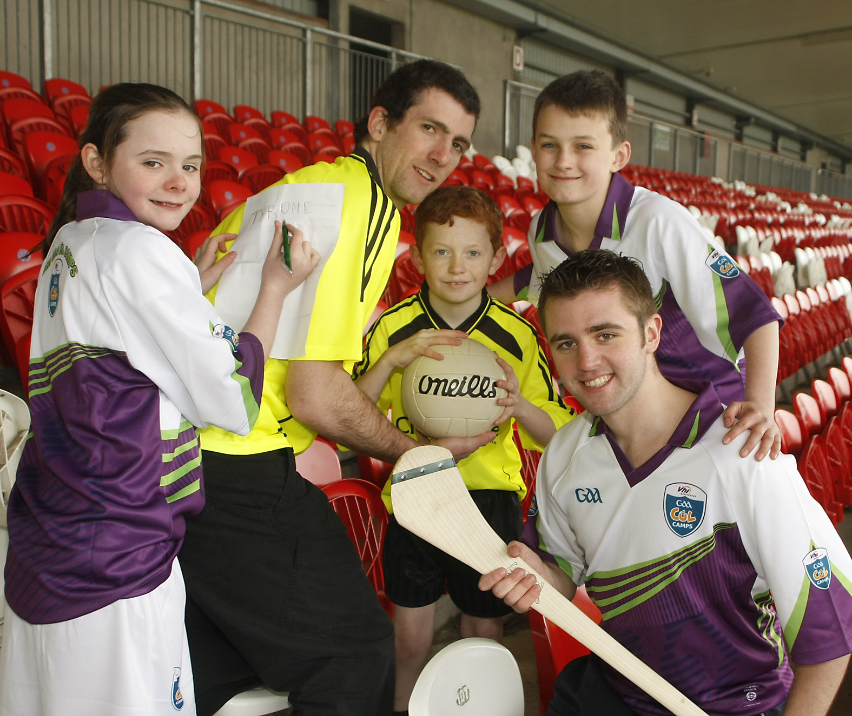
We require a large number of quality coaches, football and hurling, to make our summer camps a success. All coaches who have completed their foundation level coaching award and are actively coaching within their Club are eligible to work at the summer camps. If you are interested in some worthwhile and well organised summer work close to home, then we’d like to hear from you!

Interested?
Training day for all summer camp coaches will be held in the Dean Maguirc College, Carrickmore on Saturday 5th June at 10am. All coaches interested in working at this years camps are requested to attend.

All coaches wishing to coach at the summer camps are required to be vetted through Access NI, please bring a copy of your Access NI clearance document along to the training day.

